1



**ATSS’s**

**Institute of Industrial and Computer Management and Research, Nigdi Pune**

**MCA Department Academic Year :2022-23**

Practical Journal on

IT11L- Data Structure and Algorithms (SEM-I)

**SubmitEd By:**



Submitted by:

Name Nishant Kumar

Roll no: 27

Seat no: 20286



**ATSS’s**

**Institute of Industrial and Computer Management and Research, Nigdi Pune**

**MCA Department**

**INDEX**

**Student Name. Nishant Kumar**

**Roll No. 27**

|  |  |  |  |  |  |
| --- | --- | --- | --- | --- | --- |
| **Sr. No** | **Program Title** | **Course Outcome** | **Page No.** | **Teacher’s Sign with Date** | **Remarks** |
| **1.** | Write a program to implement  Singly linked list with required member function(Create, insert, delete, Display) |  |  |  |  |
| **2.** | Write a program to implement  Doubly linked list with required member function(Create, insert, delete, Display ) |  |  |  |  |
| **3.** | Write a program to implement STACK using Array with PUSH, POP operations |  |  |  |  |
| **4.** | Write a program to implement Stack using Linked List |  |  |  |  |
| **5.** | Write a application of stack to Check for balanced parentheses. |  |  |  |  |
| **6.** | Write a program to Reverse a string using stack |  |  |  |  |
| **7.** | Write a program to implement  Linear Queue, |  |  |  |  |
| **8.** | Write a program to Reverse stack using queue |  |  |  |  |
| **9.** | Write a program to implement binary search  tree with its operations |  |  |  |  |
| **10.** | Write a program to implement  Circular Queue, |  |  |  |  |
| **11.** | Write a Program to print Adjacancy Matrix and AdjacancyList by reading Edges of Graph |  |  |  |  |
| **12.** | Write a Program to find the element in an array using Binary Search |  |  |  |  |
| **13.** | Write a Program to find the element in an array using Linear Search |  |  |  |  |

|  |  |  |  |  |  |
| --- | --- | --- | --- | --- | --- |
| **14.** | Write a Program to implement the following 1.Print Pascal’s triangle for n=5 |  |  |  |  |
| **15.** | Write a Program to implement the following GCD of two numbers using Euclidean  Algorithm |  |  |  |  |
| **16.** | Write a program to implement  1. tower of Hanoi where number of disks=4 |  |  |  |  |
| **17.** | Write a program to implement  2. Fibonacci series till N |  |  |  |  |

Q.1 Write a program to implement

Singly linked list with required member function(Create, insert, delete, Display)

# Solution: Program

class Node{ constructor(data)

{

this.data = data; this.next = null

}

}

class LinkedList { constructor()

{

this.head = null; this.tail = null; this.size = 0; this.pos;

}

InsertAtBegin(data){

var temp = new Node(); if(this.head==null){

this.head = temp; this.size++;

}

else{

temp.next=this.head; this.head=temp; this.size++;

}

}

InsertAtEnd(data){

var temp = new Node(); temp.data = data; temp.next=null;

if(this.head==null){ this.head = temp; this.size++;

}

else{

var current = this.head; while(current.next!=null){

current=current.next;

}

current.next = temp; this.size++;

}

}

InsertAtPosition(data,pos){ var temp = new Node(); temp.data = data; temp.next=null;

if(pos<0 || pos>=this.size+2){ console.log('Invalid Position :(');

}

else{

if(pos==1){ InsertAtBegin(data);

}

else if(pos==this.size+1){ InsertAtEnd(data);

}

else{

var current = this.head; var index = 1; while(index<pos-1){

current = current.next; index++;

}

temp.next = current.next; current.next = temp; this.size++;

}

}

}

DeleteAtFirst(){ if(this.head==null){

console.log('List Is Empty');

}else{

if(this.head.next==null){ var temp = this.head; this.head=null;

// this.tail=null; this.size--;

}

else{

this.temp = this.head; this.head = this.head.next; this.size--;

}

}

}

DeleteAtLast(){ if(this.head==null){

console.log('List Is Empty');

}

else{

if(this.head.next==null){ var temp = head; this.head=null;

// this.tail=null; this.size--;

}else{

var second_last = this.head;

while (second_last.next.next != null) second_last = second_last.next;

second_last.next = null; this.size--;

}

}

}

DeleteAtPos(pos){

if(pos<=0 || pos>this.size){ console.log("Invalid pos:(");

}

else if(pos==1){ this.DeleteAtFirst();

}

else if(pos==this.size){ this.DeleteAtLast();

}

else{

var temp = new Node(); var trv = this.head;

var index = 1; while(index<pos-1){

trv = trv.next; index++;

}

temp = trv.next; trv.next=temp.next; temp.next = null; this.size--;

}

}

Display(){

var current=this.head; if(this.head==null){

console.log("List is Empty :(")

}

else{

while(current!=null){ console.log(current.data+" "); current=current.next;

}

}

}

}

L1 = new LinkedList(); L1.InsertAtBegin(20); L1.InsertAtBegin(30); L1.InsertAtBegin(40); L1.InsertAtEnd(100); L1.InsertAtPosition(3,3); console.log("After Inserting Element: "); L1.Display();

console.log("Size of LL :"+L1.size); console.log("After Deleting Element: "); L1.DeleteAtFirst();

L1.DeleteAtLast(); L1.DeleteAtPos(2); L1.Display();

console.log("Size of LL :"+L1.size);

# Output:

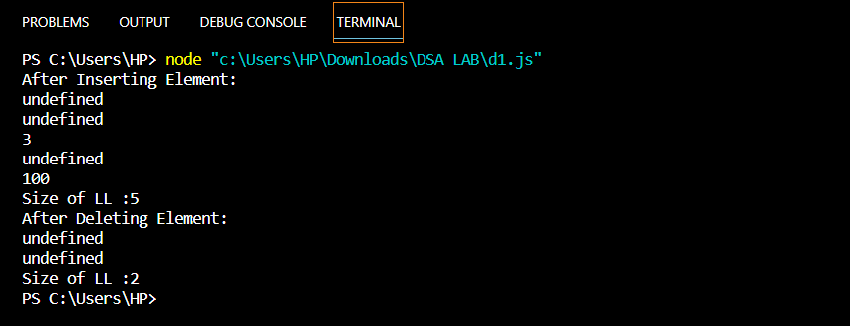

Q2. Write a program to implement

Doubly linked list with required member function(Create, insert, delete, Display

)

# Solution:

class DNode{ constructor(data)

{

this.data = data; this.next = null this.pre = null;

}

}

class DoublyLL{

constructor(){ this.head = null; this.tail = null; this.pre = null; this.size = 0; this.pos;

}

InsertAtBegin(data){

var temp = new DNode(data); temp.pre = null;

temp.next = null; temp.data = data;

if(this.head==null){ this.head = temp; this.tail = temp; this.size++;

}else{

temp.next = this.head; this.head.pre = temp; this.head = temp; this.size++;

}

}

InsertAtLast(data){

var temp = new DNode(data); if(this.head==null){

this.head=temp; this.tail=temp; this.size++;

}

else{

var trv = this.head; while(trv.next!=null){

trv = trv.next;

}

trv.next=temp; temp.pre = trv; this.tail = temp; this.size++;

}

}

InsertAtPos(data,pos){

var temp = new DNode(data); if(pos<0 || pos>=this.size+2){ console.log("Invalid Pos:(");

}

else{

if(pos==1){ InsertAtBegin(data);

}

else if(pos==this.size+1){ InsertAtEnd(data);

}

else{

var current = this.head; var index = 1; while(index<pos-1){

current = current.next; index++;

}

temp.next = current.next; current.next = temp; temp.next.pre = temp; this.size++;

}

}

}

DeleteAtFirst(){ if(this.head==null){

console.log('List Is Empty');

}else{

if(this.head.next==null){ var temp = this.head; this.head=null;

// this.tail=null; this.size--;

}

else{

temp = this.head; this.head = this.head.next; this.head.pre = null; this.size--;

}

}

}

DeleteAtLast(){ if(this.head==null){

console.log('List Is Empty');

}

else{

if(this.head.next==null){ var temp = head; this.head=null;

// this.tail=null; this.size--;

}else{

var trv = this.head; while(trv.next!=null){ trv=trv.next;

}

trv = trv.pre; temp = trv.next; trv.next = null; this.size--;

}

}

}

DeleteAtPos(pos){

if(pos<=0 || pos>this.size){ console.log("Invalid pos:(");

}

else if(pos==1){ this.DeleteAtFirst();

}

else if(pos==this.size){ this.DeleteAtLast();

}

else{

var temp = new DNode(); var trv = this.head;

var index = 1; while(index<pos-1){

trv = trv.next; index++;

}

temp = trv.next; trv.next.pre = trv; this.size--;

}

}

Display(){

var current=this.head; if(this.head==null){

console.log("List is Empty :(")

}

else{

while(current!=null){ console.log(current.data+" "); current=current.next;

}

}

}

}

var DLL = new DoublyLL(); DLL.InsertAtLast(99); DLL.InsertAtBegin(30); DLL.InsertAtBegin(40); DLL.InsertAtLast(78); DLL.InsertAtPos(44,3) console.log("After Inserting Element: ");

DLL.Display();

console.log("Size of LL :"+DLL.size); console.log("After Deleting Element: "); DLL.DeleteAtFirst(); DLL.DeleteAtLast(); DLL.DeleteAtPos(2);

DLL.Display();

console.log("Size of LL :"+DLL.size);

# OUTPUT:

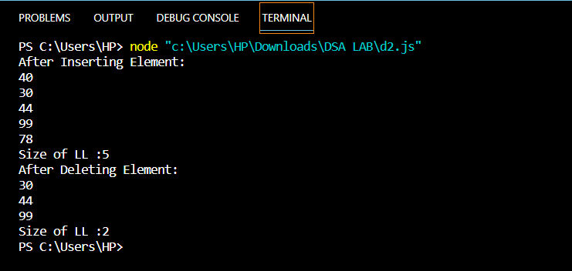

**Q3.** Write a program to implement STACK using Array with PUSH, POP operations

# Solution:

class Stack{ constructor(sz){

this.Arr = new Array(sz); this.top=-1;

this.size=sz;

}

isFull(){

if(this.size==this.size-1) return true;

else

return false;

}

isEmpty(){ if(this.top==-1)

return true; else

return false;

}

push(data){ if(this.isFull()){

console.log("Stack Is Full :");

}

else{

this.top++; this.Arr[this.top] = data;

}

}

pop(){

if(this.isEmpty()){ console.log("Stack Is Empty :");

}

else{

var t = this.Arr[this.top]; this.top--;

}

return t;

}

display(){

var str = " ";

for(let i=0;i<=this.top;i++){ str+=this.Arr[i]+" ";

}

console.log(str);

}

}

let s1 = new Stack(5); s1.push(39);

s1.push(74);

s1.push(87);

s1.push(44);

s1.push(96);

s1.push(67);

s1.display();

console.log("Poped element is : "+s1.pop()); s1.display();

# OUTPUT:

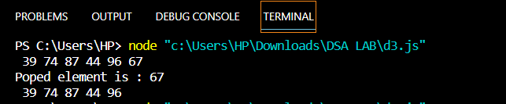

**Q4.** Write a program to implement Stack using Linked List

# Solution:

class StackNode{ constructor(data){

this.data=data; this.next=null;

}

}

class StackLL{

constructor(s){ this.top=null; this.cnt=0; this.size=s;

}

GetSize(){

return this.cnt;

}

IsEmpty(){ if(this.top==null)

return 1; else

return 0;

}

IsFull(){

if(this.cnt==this.size) return 1;

else

return 0;

}

push(data){ if(this.IsFull()){

console.log("Stack Is Full..."); return;

}

var temp = new StackNode(data); if(this.top==null){

this.top++; this.top=temp; this.cnt++;

}

else{

temp.next=this.top; this.top=temp; this.cnt++;

}

}

pop(){

if(this.IsEmpty()){ console.log("Stack is Empty. "); return;

}

else{

var t = this.top; this.top=t.next; this.cnt--; return t.data;

}

}

Display(){ if(this.top==null){

console.log("List is Empty...") return;

}

else{

var current=this.top; while(current!=null){

console.log(current.data+" "); current=current.next;

}

}

}

}

let s1 = new StackLL(5); s1.push(16);

s1.push(8);

s1.push(4);

s1.push(2);

s1.push(1);

s1.push(2);

s1.Display();

console.log("Popped Elment is: "+s1.pop()); s1.Display();

# OUTPUT:

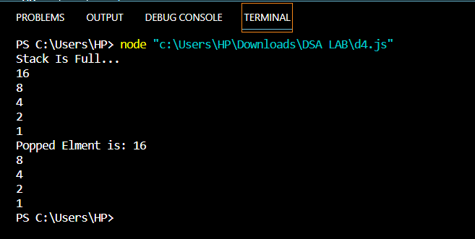

**Q5.** Write a application of stack to Check for balanced parentheses.

# Solution:

// Stack class Node {

constructor(value) { this.value = value; this.next = null;

}

}

class Stack { constructor(size) { this.data = []; this.size = size; this.top = -1;

this.length = 0;

}

isEmpty() {

if (this.length === 0) { return true;

}

return false;

}

isFull() {

if (this.length === this.size) { return true;

}

return false;

}

// unshift add element at first push(value) {

if (this.isFull()) { return 'Stack is full';

}

this.top++; this.data[this.top] = value; this.length++;

return true;

}

// shift //remove element from first pop() {

if (this.isEmpty()) return 'Stack is empty'; else {

let removeElm = this.data[this.top]; this.data.pop();

this.top--; this.length--;

return removeElm;

}

}

display() {

for (let i = 0; i < this.length; i++) { console.log(this.data[i]);

}

}

}

const parenthesisChecker = (str) => { const s = new Stack();

for (let i of str) {

if (i == '(' || i == '[' || i == '{') { s.push(i);

}

if (i == ')' || i == ']' || i == '}') { s.pop();

}

}

if (!s.length) {

console.log(`Valid parenthesis`);

} else {

console.log(`In-valid parenthesis`);

}

};

parenthesisChecker('(a+b)+(a-b)'); parenthesisChecker('(a+b)+(a-b)[+[a/b]{');

# OUTPUT:

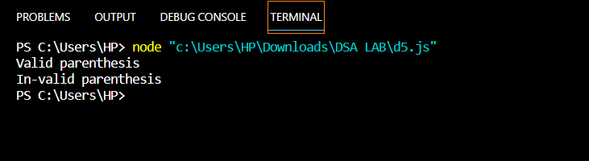

**Q6.** Write a program to Reverse a string using stack

# Solution:

class Stack{ constructor(n){

this.top = -1; this.size = n;

this.a = new Array(this.size);

}

isEmpty(){ return(this.top < 0);

}

push(x){

if (this.top >= this.size){ console.log("Stack Overflow<br>"); return false;

}

else{

this.a[++this.top] = x; return true;

}

}

pop(){

if (this.top < 0){

console.log("Stack Underflow<br>"); return 0;

}

else{

let x = this.a[this.top--]; return x;

}

}

}

function reverse(str){

let n = str.length;

let obj = new Stack(n);

let i;

for(i = 0; i < n; i++) obj.push(str[i]);

for(i = 0; i < n; i++){ let ch = obj.pop(); str[i] = ch;

}

}

let p = "JavaScript".split(""); reverse(p);

console.log("Reversed string is " +p.join(""));

# OUTPUT:

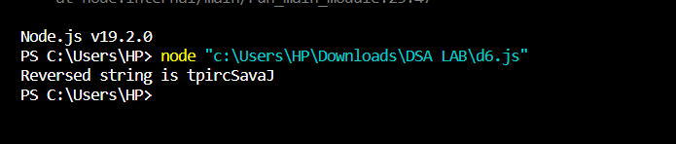

**Q7.** Write a program to implement Linear Queue

# Solution:

class Queue { constructor(size) { this.data = []; this.front = -1;

this.rear = -1; this.size = size; this.length = 0;

}

isEmpty() {

return this.length === 0;

}

isFull() {

return this.length === this.size;

}

enqueue(value) {

if (this.isFull()) return 'Queue is full'; if (this.isEmpty()) {

this.rear++; this.front++;

this.data[this.front] = value;

} else { this.rear++;

this.data[this.rear] = value;

}

this.length++; return true;

}

dequeue() {

if (this.isEmpty()) return 'Queue is empty'; if (this.length === 1) {

var removeNode = this.data[this.front]; this.data[this.front] = null;

this.front = -1;

this.rear = -1;

} else {

var removeNode = this.data[this.front]; this.data[this.front] = null;

this.front++;

}

this.length--;

return `removeNode is ${removeNode}`;

}

display() {

if (this.front === -1) return null;

for (let i = this.front; i <= this.rear; i++) { console.log(this.data[i]);

}

}

}

let q = new Queue(4); q.enqueue(7);

q.enqueue(9); q.enqueue(21); q.enqueue(11);

console.log("After Insertion in Queu: "); q.display();

console.log(q.dequeue()); console.log(q.dequeue()); console.log("After Deletion in Queue: "); q.display();

# OUTPUT:

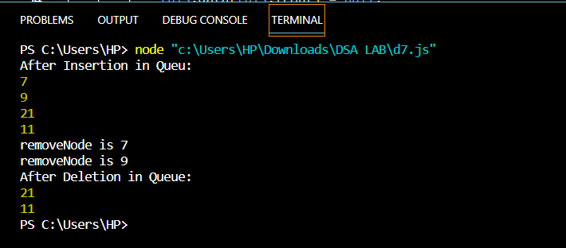

**Q8** Write a program to Reverse stack using queue

# Solution:

class Node { constructor(value) { this.value = value; this.next = null;

}

}

class Stack { constructor(size) { this.data = []; this.size = size; this.top = -1;

this.length = 0;

}

isEmpty() {

if (this.length === 0) { return true;

}

return false;

}

isFull() {

if (this.length === this.size) { return true;

}

return false;

}

// unshift add element at first unShift(value) {

if (this.isFull()) { return 'Stack is full';

}

this.top++; this.data[this.top] = value; this.length++;

return true;

}

// shift //remove element from first shift() {

if (this.isEmpty()) return 'Stack is empty'; else {

let removeElm = this.data[this.top]; this.data.pop();

this.top--; this.length--;

return removeElm;

}

}

display() {

for (let i = 0; i < this.length; i++) { console.log(this.data[i]);

}

}

}

// Queue class Queue {

constructor(size) { this.data = []; this.front = -1;

this.rear = -1; this.size = size; this.length = 0;

}

isEmpty() {

return this.length === 0;

}

isFull() {

return this.length === this.size;

}

// rear - back enqueue(value) {

if (this.isFull()) return 'Queue is full'; if (this.isEmpty()) {

this.rear++; this.front++;

this.data[this.front] = value;

} else { this.rear++;

this.data[this.rear] = value;

}

this.length++; return true;

}

dequeue() {

if (this.isEmpty()) return 'Queue is empty'; if (this.length === 1) {

var removeNode = this.data[this.front]; this.data[this.front] = null;

this.front = -1;

this.rear = -1;

} else {

var removeNode = this.data[this.front]; this.data[this.front] = null; this.front++;

}

this.length--; return removeNode;

}

display() {

if (this.front === -1) return null;

for (let i = this.front; i <= this.rear; i++) { console.log(this.data[i]);

}

}

}

const reverse = () => { const s = new Stack(); const q = new Queue();

s.unShift(93); s.unShift(48); s.unShift(87); s.unShift(13); s.unShift(21);

console.log(`Stack is`); s.display();

while (s.length) { q.enqueue(s.shift());

}

while (q.length) { s.unShift(q.dequeue());

}

console.log(`After reversing stack using queue`); s.display();

};

reverse();

# OUTPUT:

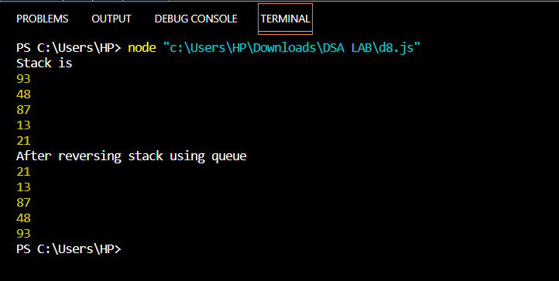

**Q9** Write a program to implement binary search tree with its operations

# Solution:

class Node { constructor(value) {

this.value = value; this.left = null; this.right = null;

}

}

class BinarySearchTree { constructor() {

this.root = null;

}

insert(value) {

const newNode = new Node(value);

if (this.root === null) { this.root = newNode;

} else {

let current = this.root; while (true) {

if (value === current.value) return undefined; if (value < current.value) {

if (current.left === null) { current.left = newNode; return this;

}

current = current.left;

} else {

if (current.right === null) { current.right = newNode; return this;

}

current = current.right;

}

}

}

}

find(value) {

if (this.root === null) return false;

let current = this.root; let found = false;

while (current && !found) { if (value < current.value) {

current = current.left;

} else if (value > current.value) { current = current.right;

} else {

found = true;

}

}

if (!found) return false; return current;

}

bfs() {

let node = this.root; let queue = [];

let data = []; queue.push(node);

while (queue.length) { node = queue.shift(); data.push(node.value);

if (node.left) queue.push(node.left); if (node.right) queue.push(node.right);

}

return data;

}

dfsPreOrder() { let data = [];

function traverse(node) { data.push(node.value);

if (node.left) traverse(node.left); if (node.right) traverse(node.right);

}

traverse(this.root); return data;

}

dfsPostOrder() { let data = [];

function traverse(node) {

if (node.left) traverse(node.left); if (node.right) traverse(node.right); data.push(node.value);

}

traverse(this.root); return data;

}

dfsInOrder() { let data = [];

function traverse(node) {

if (node.left) traverse(node.left); data.push(node.value);

if (node.right) traverse(node.right);

}

traverse(this.root); return data;

}

}

const bst = new BinarySearchTree();

// Insert nodes bst.insert(10); bst.insert(5); bst.insert(13); bst.insert(11); bst.insert(2); bst.insert(16); bst.insert(7);

console.log("Find Nodes: ");

console.log(bst.find(7)); // Node { value: 7, left: null, right: null } console.log(bst.find(12)); // false

console.log("Breadth-first search traversal : "); console.log(bst.bfs()); // [ 10, 5, 13, 2, 7, 11, 16 ]

console.log("Depth-first search traversal - Pre-order : ") console.log(bst.dfsPreOrder()); // [ 10, 5, 2, 7, 13, 11, 16 ]

console.log("Depth-first search traversal - Post-order : "); console.log(bst.dfsPostOrder()); // [ 2, 7, 5, 11, 16, 13, 10 ]

console.log("Depth-first search traversal - In-order : "); console.log(bst.dfsInOrder()); // [ 2, 5, 7, 10, 11, 13, 16 ]

# OUTPUT:

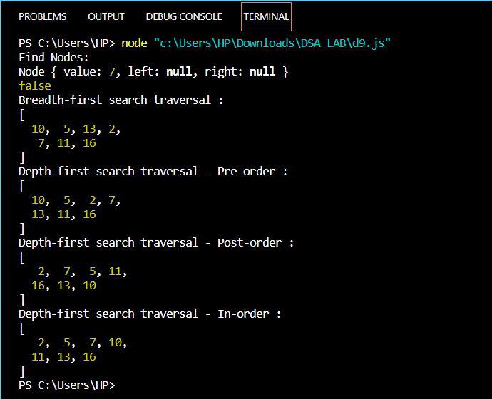

Q10 Write a program to implement Circular Queue

# Solution:

class Queue {

constructor(size) { this.Arr = new Array(); this.front = -1;

this.rare = -1; this.size = size;

}

isEmpty() {

if (this.front == -1) { return 1;

} else { return 0;

}

}

isFull() { if (

(this.front == 0 && this.rare == this.size - 1) || this.rare + 1 == this.front

) {

return 1;

} else { return 0;

}

}

EnQueue(val) {

if (this.isFull()) { console.log("Queue is full.."); return;

} else if (this.isEmpty()) { this.front++; this.rare++; this.Arr[this.rare] = val;

} else {

this.rare = this.rare + (1 % this.size); this.Arr[this.rare] = val;

}

}

DeQueue() {

if (this.isEmpty()) {

console.log("Queue is empty");

} else if (this.front == this.rare) { var val = Arr[this.front]; this.front = -1;

this.rare = -1;

//return val;

} else {

var val = this.Arr[this.front]; this.front = (this.front + 1) % this.size;

//return val;

}

}

Display() { var str = "";

for (var i = this.front; i != this.rare; i = i + (1 % this.size)) { str = str + this.Arr[i] + " ";

}

str = str + this.Arr[i] + " "; console.log(str);

}

}

const qobj = new Queue(7); qobj.EnQueue(15); qobj.EnQueue(20); qobj.EnQueue(30); qobj.EnQueue(45); qobj.EnQueue(50); qobj.Display(); qobj.DeQueue(); qobj.Display();

# OUTPUT:

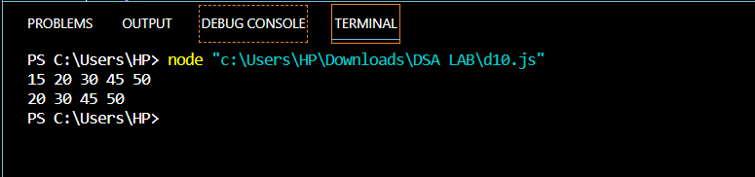

Q11. Write a Program to print Adjacancy Matrix and AdjacancyList by reading Edges of Graph

# Solution:

function createMatrix(n) { const matrix = [];

for (let i = 0; i < n; i++) { matrix.push(new Array(n).fill(0));

}

return matrix;

}

const input = prompt("Enter the edges of the graph, separated by spaces:"); const edges = input.split(" ");

let n = 0;

for (let i = 0; i < edges.length; i++) { const [u, v] = edges[i].split(",");

n = Math.max(n, parseInt(u), parseInt(v));

}

const matrix = createMatrix(n + 1);

const list = new Array(n + 1).fill(null).map(() => []); for (let i = 0; i < edges.length; i++) {

const [u, v] = edges[i].split(","); matrix[u][v] = 1;

list[u].push(v);

}

document.write("Adjacency matrix:"); document.write("</br>");

for (let i = 1; i <= n; i++) { document.write(matrix[i].join(" "));

document.write("</br>");

}

document.write("</br>"); document.write("Adjacency list:"); document.write("</br>");

for (let i = 1; i <= n; i++) { document.write(`${i}: ${list[i].join(", ")}`);

document.write("</br>");

}

OUTPUT:

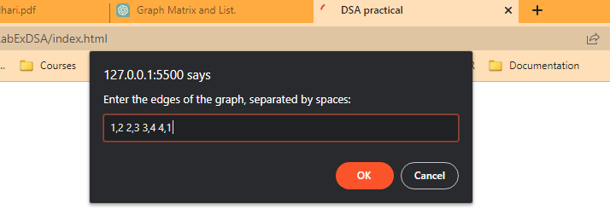

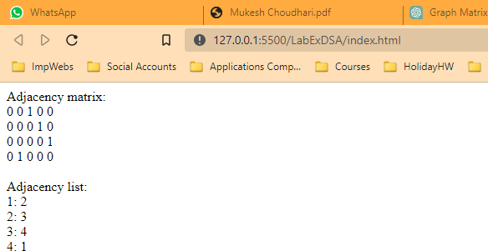

Q12. Write a Program to find the element in an array using Binary Search

# Solution:

function binarySearch(arr, val) { let start = 0;

let end = arr.length - 1;

while (start <= end) {

let mid = Math.floor((start + end) / 2);

if (arr[mid] === val) { return mid;

} else if (arr[mid] < val) { start = mid + 1;

} else {

end = mid - 1;

}

}

return -1;

}

const arr = [1, 3, 5, 7, 9]; const val = 5;

console.log(binarySearch(arr, val)); // outputs 2

OUTPUT:

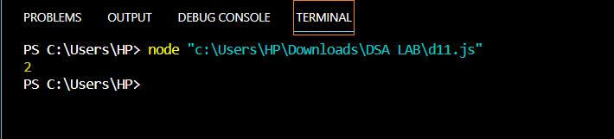

Q13. Write a Program to find the element in an array using Linear Search

# Solution:

function linearSearch(arr, target) { for (let i = 0; i < arr.length; i++) {

if (arr[i] === target) { return i;

}

}

return -1;

}

const array = [3, 6, 1, 4, 2, 8]; const targetElement = 8;

const index = linearSearch(array, targetElement);

if (index !== -1) {

console.log(`The element ${targetElement} was found at index ${index}.`);

} else {

console.log(`The element ${targetElement} was not found in the array.`);

}

OUTPUT:

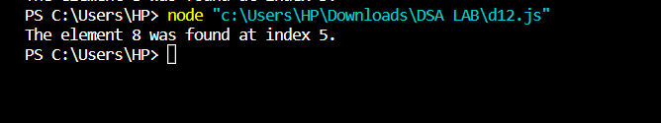

Q14. Write a Program to implement the following .Print Pascal’s triangle for n=5

# Solution:

function pascalsTriangle(n) { const triangle = [];

for (let i = 0; i < n; i++) { const row = [];

for (let j = 0; j <= i; j++) { if (j === 0 || j === i) {

row.push(1);

} else {

const prevRow = triangle[i - 1]; row.push(prevRow[j - 1] + prevRow[j]);

}

}

triangle.push(row);

}

for (let i = 0; i < n; i++) { console.log(triangle[i].join(' '));

}

}

pascalsTriangle(5);

OUTPUT:

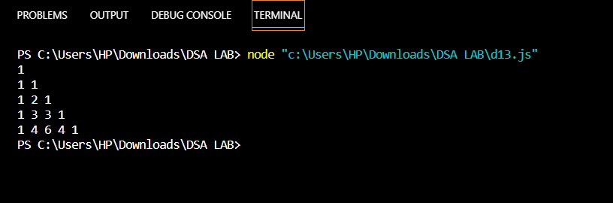

Q15. Write a Program to implement the following GCD of two numbers using Euclidean Algorithm.

# Solution:

function gcd(a, b) { if (a < b) {

[a, b] = [b, a];

}

while (b !== 0) { const temp = b; b = a % b;

a = temp;

}

return a;

}

const a = 84; const b = 18;

const result = gcd(a, b); console.log(result); // Output: 6

OUTPUT:

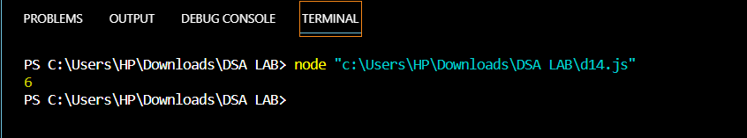

Q16. Write a program to implement tower of Hanoi where number of disks=4

# Solution:

function towerOfHanoi(n, source, destination, auxiliary) { if (n === 1) {

console.log(`Move disk 1 from ${source} to ${destination}`); return;

}

towerOfHanoi(n - 1, source, auxiliary, destination); console.log(`Move disk ${n} from ${source} to ${destination}`); towerOfHanoi(n - 1, auxiliary, destination, source);

}

towerOfHanoi(4, 'A', 'C', 'B');

OUTPUT:

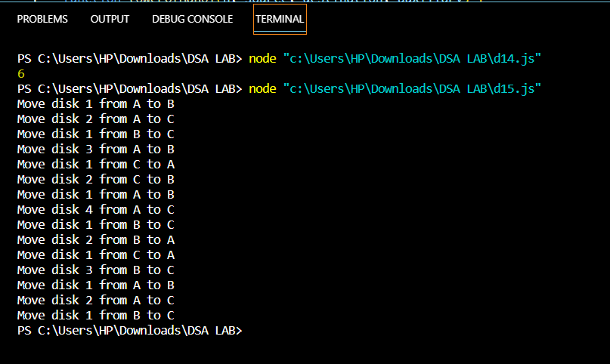

Q17. Write a program to implement Fibonacci series till N

# Solution:

function fibonacciSeries(n) { if (n < 1) {

return [];

}

if (n === 1) { return [0];

}

let series = [0, 1];

while (series.length < n) { let len = series.length;

series.push(series[len - 1] + series[len - 2]);

}

return series;

}

console.log(fibonacciSeries(10));

OUTPUT:

